**“Experiment 1.3”**

Student Name: **SUMIT KUMAR** UID: **20BCS8226**

Branch: **CSE** Section/Group: **808-A**

Semester: **5** Date of Performance: **18-08-22**

Subject Name: **PBLJ Lab** Subject Code: **20CSP-321**

**AIM:**

Create an application to calculate interest for FDs, RDs based on certain conditions using inheritance.

**Minimum Hardware Requirements:**

* 2 GHz CPU or 1 virtual CPU in virtualized environments.
* 1 GB of RAM.
* 4 GB of storage.

**Minimum Software Requirements:**

|  |  |
| --- | --- |
| **Software** | **Version** |
| * OS | * Mac OS 10.15, HP-UX 11i V3, AIX 7.2, Windows Server 2019, Windows 10, Solaris 11.3, Red Hat Enterprise Linux 8.1, Ubuntu Server 20.04 |
| * JDK | * JDK 1.8.0, JDK 11, Ellipse IDE, Net, NetBeans 8.2 |

**Algorithm:**

1. Make Account Class.
2. Using Method Overriding Create Interest Calculate.
3. Create FD, RD & SD.
4. Take input of amount and age and days for FD.
5. Take input of saving account
6. For RD take amount and month and age as input.
7. Create a Launcher class.

**Source Code:**

// SUMIT KUMAR

// UID: 20BCS8226

**package** practice2;

**import** java.util.*;

**interface** Account{

**double** ***interestrate***=0.0;

**double** ***amount***=0.0;

**abstract** **double** calculateInterest();

}

**class** SBAccount **implements** Account{

**private** **double** interestrate;

**private** **double** amount;

**double** gainedInterest;

**public** **double** calculateInterest(){

Scanner sc=**new** Scanner(System.***in***);

System.***out***.println("Enter the average in your account");

amount=sc.nextDouble();

System.***out***.println("Enter 1 for Normal account or 2 for NRI account");

**int** typeofacc=sc.nextInt();

**if**(amount <= 0)

{

System.***out***.println("Please enter Valid Amount.");

}

**else**{

**if**(typeofacc==1){

gainedInterest=((amount*4)/100);

System.***out***.println("Interest gained "+gainedInterest);

}

**else** **if**(typeofacc == 2){

gainedInterest=((amount*6)/100);

System.***out***.println("Interest gained "+gainedInterest);

}

**else**{

System.***out***.println("invalid selection");

}

}

**return** 0;

}

}

**class** FDAccount **implements** Account{

**private** **double** interestrate;

**private** **double** amount;

**private** **int** noOfDays;

**int** ageOfACHolder;

**double** gainedInterest;

**public** **double** calculateInterest(){

System.***out***.println("Enter the FD amount:");

Scanner sc=**new** Scanner(System.***in***);

amount=sc.nextDouble();

System.***out***.println("Enter the no of days:");

noOfDays=sc.nextInt();

System.***out***.println("Enter your age:");

ageOfACHolder=sc.nextInt();

**if**(amount<10000000){

**if**(noOfDays>=7 && noOfDays<=14){

**if**(ageOfACHolder<=60){

interestrate=4.50;

gainedInterest=(amount*interestrate)/100;

System.***out***.println("Interest gained is: "+gainedInterest);

}

**else**{

interestrate=5.0;

gainedInterest=(amount*interestrate)/100;

System.***out***.println("Interest gained is: "+gainedInterest);

}

}

**else** **if**(noOfDays>=15 && noOfDays<=29){

**if**(ageOfACHolder<=60){

interestrate=4.75;

gainedInterest=(amount*interestrate)/100;

System.***out***.println("Interest gained is: "+gainedInterest);

}

**else**{

interestrate=5.25;

gainedInterest=(amount*interestrate)/100;

System.***out***.println("Interest gained is: "+gainedInterest);

}

}

**else** **if**(noOfDays>=30 && noOfDays<=45){

**if**(ageOfACHolder<=60){

interestrate=5.50;

gainedInterest=(amount*interestrate)/100;

System.***out***.println("Interest gained is: "+gainedInterest);

}

**else**{

interestrate=6.00;

gainedInterest=(amount*interestrate)/100;

System.***out***.println("Interest gained is: "+gainedInterest);

}

}

**else** **if**(noOfDays>=46 && noOfDays<=60){

**if**(ageOfACHolder<=60){

interestrate=7;

gainedInterest=(amount*interestrate)/100;

System.***out***.println("Interest gained is: "+gainedInterest);

}

**else**{

interestrate=7.50;

gainedInterest=(amount*interestrate)/100;

System.***out***.println("Interest gained is: "+gainedInterest);

}

}

**else** **if**(noOfDays>=61 && noOfDays<=184){

**if**(ageOfACHolder<=60){

interestrate=7.50;

gainedInterest=(amount*interestrate)/100;

System.***out***.println("Interest gained is: "+gainedInterest);

}

**else**{

interestrate=8.00;

gainedInterest=(amount*interestrate)/100;

System.***out***.println("Interest gained is: "+gainedInterest);

}

}

**else** **if**(noOfDays>=185 && noOfDays<=365){

**if**(ageOfACHolder<=60){

interestrate=8.00;

gainedInterest=(amount*interestrate)/100;

System.***out***.println("Interest gained is: "+gainedInterest);

}

**else**{

interestrate=8.50;

gainedInterest=(amount*interestrate)/100;

System.***out***.println("Interest gained is: "+gainedInterest);

}

}

**else** {System.***out***.println("Please Provide Valid days.");}

}

**else**{

**if**(noOfDays>=7 && noOfDays<=14){

interestrate=6.50;

gainedInterest=(amount*interestrate)/100;

System.***out***.println("Interest gained is: "+gainedInterest);

}

**else** **if**(noOfDays>=15 && noOfDays<=29){

interestrate=6.75;

gainedInterest=(amount*interestrate)/100;

System.***out***.println("Interest gained is: "+gainedInterest);

}

**else** **if**(noOfDays>=30 && noOfDays<=45){

interestrate=6.75;

gainedInterest=(amount*interestrate)/100;

System.***out***.println("Interest gained is: "+gainedInterest);

}

**else** **if**(noOfDays>=46 && noOfDays<=60){

interestrate=8.00;

gainedInterest=(amount*interestrate)/100;

System.***out***.println("Interest gained is: "+gainedInterest);

}

**else** **if**(noOfDays>=61 && noOfDays<=184){

interestrate=8.50;

gainedInterest=(amount*interestrate)/100;

System.***out***.println("Interest gained is: "+gainedInterest);

}

**else** **if**(noOfDays>=185 && noOfDays<=365){

interestrate=10.00;

gainedInterest=(amount*interestrate)/100;

System.***out***.println("Interest gained is: "+gainedInterest);

}

**else** {System.***out***.println("Please Provide Valid days.");}

}

**return** 0.0;}

}

**class** RDAccount **implements** Account{

**private** **double** interestRate;

**private** **double** amount;

**private** **double** monthlyAmount;

**private** **int** ageOfACHolder;

**private** **int** noOfMonths;

**public** **double** calculateInterest(){

Scanner sc = **new** Scanner(System.***in***);

System.***out***.println("Enter the RD amount: ");

amount = sc.nextDouble();

System.***out***.println("Enter the number of months, either 6 or 9 or 12 or 15 or 18 or 21");

noOfMonths = sc.nextInt();

System.***out***.println("Enter your age: ");

ageOfACHolder = sc.nextInt();

**if**(amount <= 0.0){

System.***out***.println("Invalid RD Amount");

}

**else**{

**if** (noOfMonths == 6) {

**if**(ageOfACHolder <= 55){

interestRate = 7.5;

**double** gainedInterest = (amount * interestRate)/100;

System.***out***.println("Interest Gained is : "+gainedInterest);

}

**else**{

**double** gainedInterest = (amount * interestRate)/100;

System.***out***.println("Interest Gained is : "+gainedInterest);

}

}

**else** **if** (noOfMonths == 9) {

**if**(ageOfACHolder <= 55){

interestRate = 7.75;

**double** gainedInterest = (amount * interestRate)/100;

System.***out***.println("Interest Gained is : "+gainedInterest);

}

**else**{

interestRate = 8.25;

**double** gainedInterest = (amount * interestRate)/100;

System.***out***.println("Interest Gained is : "+gainedInterest);

}

}

**else** **if** (noOfMonths == 12) {

**if**(ageOfACHolder <= 55){

interestRate = 8.0;

**double** gainedInterest = (amount * interestRate)/100;

System.***out***.println("Interest Gained is : "+gainedInterest);

}

**else**{

interestRate = 8.5;

**double** gainedInterest = (amount * interestRate)/100;

System.***out***.println("Interest Gained is : "+gainedInterest);

}

}

**else** **if** (noOfMonths == 15) {

**if**(ageOfACHolder <= 55){

interestRate = 8.25;

**double** gainedInterest = (amount * interestRate)/100;

System.***out***.println("Interest Gained is : "+gainedInterest);

}

**else**{

interestRate = 8.75;

**double** gainedInterest = (amount * interestRate)/100;

System.***out***.println("Interest Gained is : "+gainedInterest);

}

}

**else** **if** (noOfMonths == 18) {

**if**(ageOfACHolder <= 55){

interestRate = 8.5;

**double** gainedInterest = (amount * interestRate)/100;

System.***out***.println("Interest Gained is : "+gainedInterest);

}

**else**{

interestRate = 9.0;

**double** gainedInterest = (amount * interestRate)/100;

System.***out***.println("Interest Gained is : "+gainedInterest);

}

}

**else** **if** (noOfMonths == 21) {

**if**(ageOfACHolder <= 55){

interestRate = 8.75;

**double** gainedInterest = (amount * interestRate)/100;

System.***out***.println("Interest Gained is : "+gainedInterest);

}

**else**{

interestRate = 9.25;

**double** gainedInterest = (amount * interestRate)/100;

System.***out***.println("Interest Gained is : "+gainedInterest);

}

}

**else** System.***out***.println("Please Provide Valid Months.");

}

**return** 0.0;

}

}

**public** **class** Main {

**public** **static** **void** main(String args[]){

**int** choice;

**do**{

FDAccount fda=**new** FDAccount();

SBAccount sba=**new** SBAccount();

RDAccount rda=**new** RDAccount();

System.***out***.println("MAIN MENU \n 1. Interest Calculator - SB \n 2. Interest Calculator - FD \n 3. Interest Calculator - RD \n 4. Exit");

System.***out***.println("Enter your option(1..4): ");

Scanner sc=**new** Scanner(System.***in***);

choice=sc.nextInt();

**switch** (choice){

**case** 1: sba.calculateInterest();

**break**;

**case** 2:fda.calculateInterest();

**break**;

**case** 3:rda.calculateInterest();

**break**;

**case** 4:System.***out***.println("exiting");

System.*exit*(0);

**break**;

**default**:System.***out***.println("You are enter wrong entry");

}

// if (choice == 1) {

// sba.calculateInterest();

// } else if (choice == 2) {

// fda.calculateInterest();

// } else if (choice == 3) {

// rda.calculateInterest();

// } else if (choice == 4) {

// System.out.println("exiting");

// System.exit(0);

// } else

// System.out.println("Please enter valid choice");

}**while**(choice !=4);

// catch(Exception e){

// System.out.println("Error occurred at: "+e);

// }

}

}

**Output:**

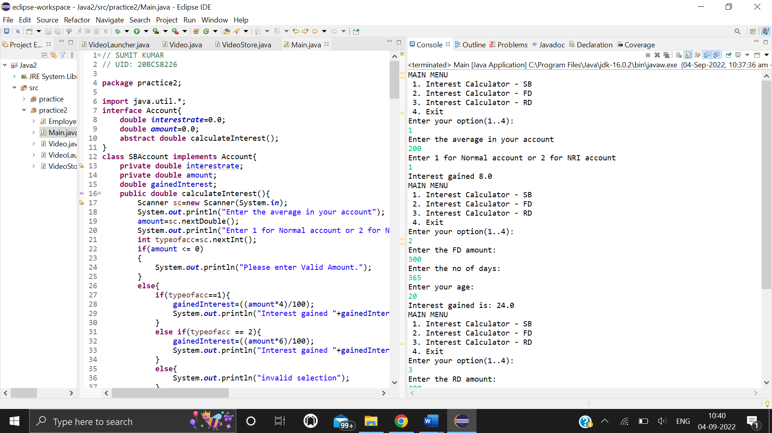

**Screenshot of executing choices 1 and 2**

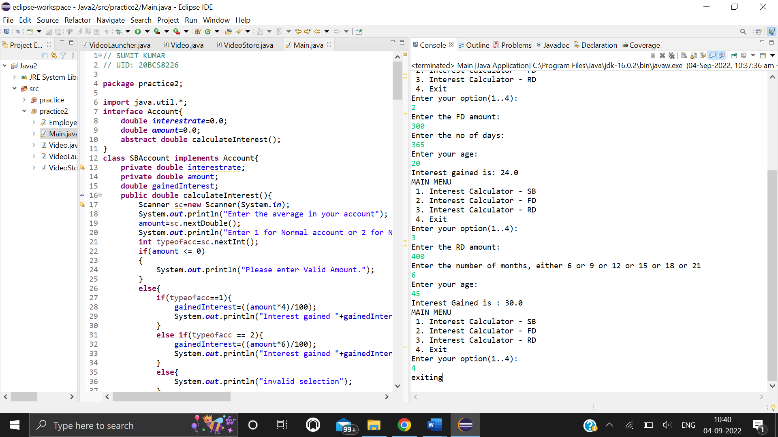

**Screenshot of executing choices 3 and 4**

**Learning outcomes:**

* Learnt how to create and import user defined packages for more understandable and modular code.
* Learnt about simple and compound interest and how to calculate them using their respective formulas.
* Learnt about the concept of inheritance in object oriented programming and how to implement it in a program.